1. **Exploratory Data Analysis**
2. **NOTE** 🡪 Pregnancy is not Normally Distributed.

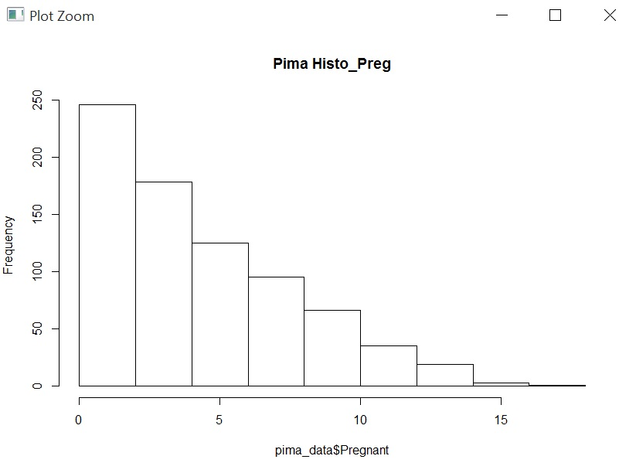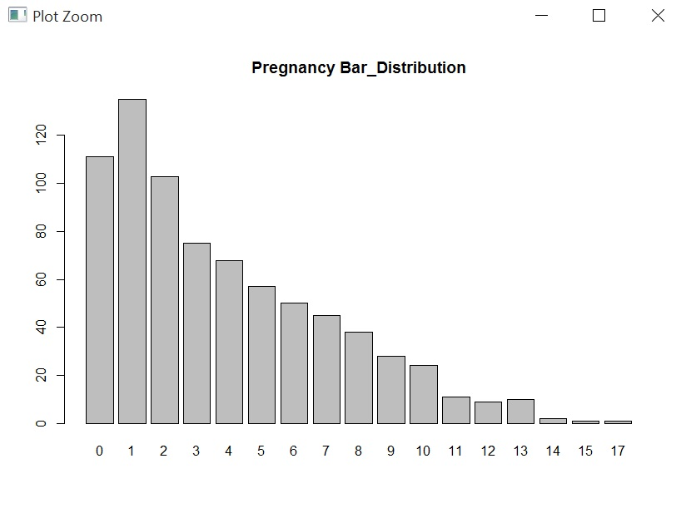

**NOTE** 🡪 Glucose is Normally Distributed.

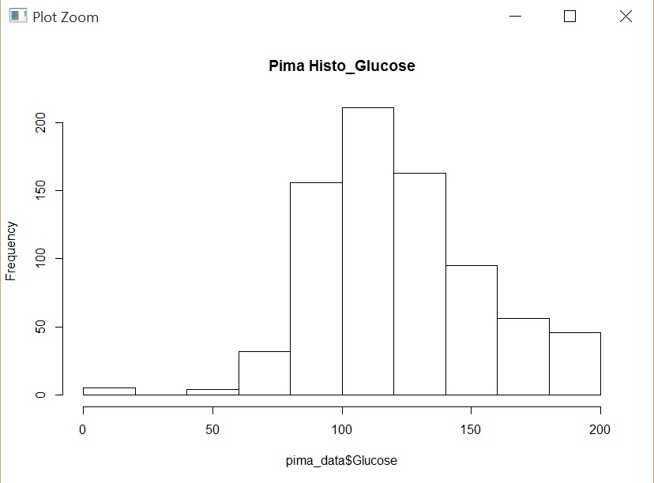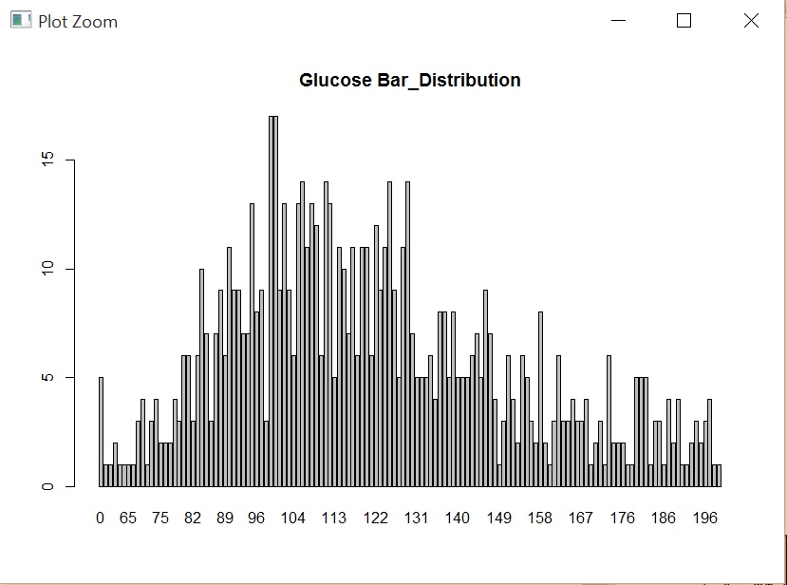

**NOTE** 🡪 BP is Normally Distributed.

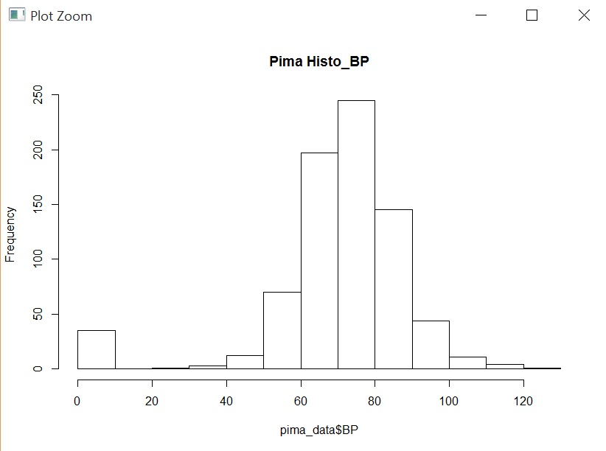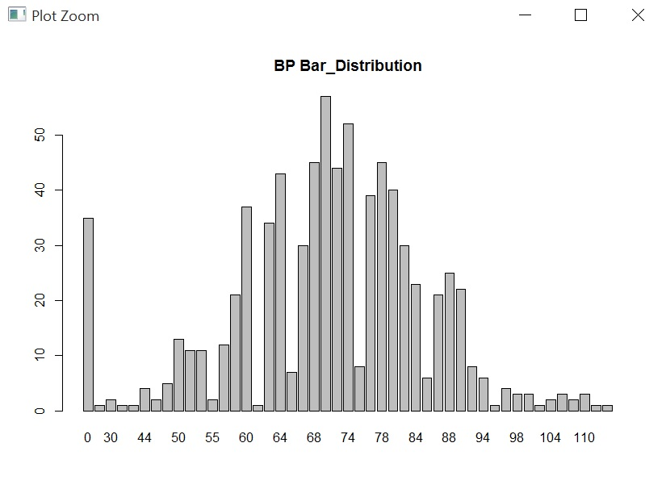

**NOTE** 🡪 Thickness is not Normally Distributed.

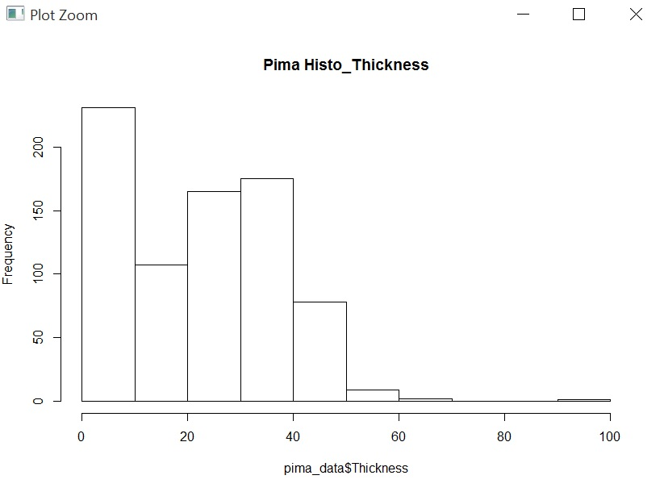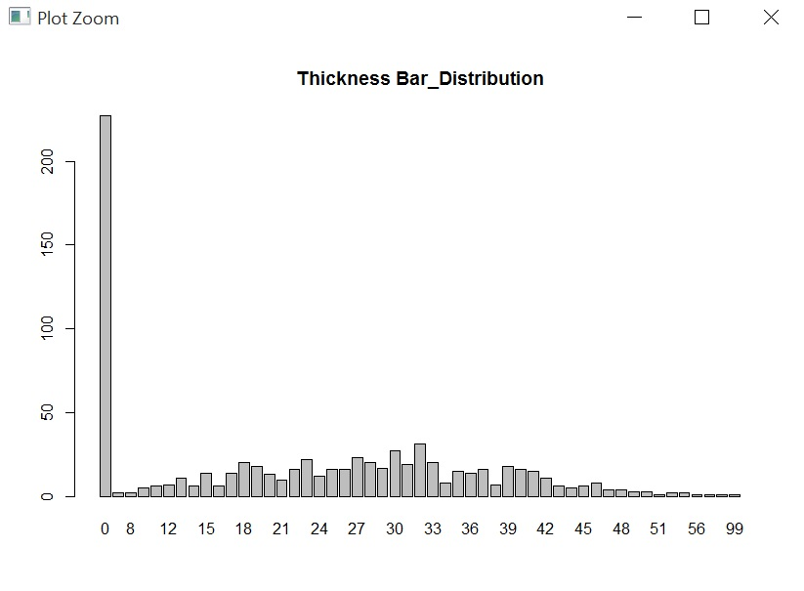

**NOTE** 🡪 Insulin is not Normally Distributed.

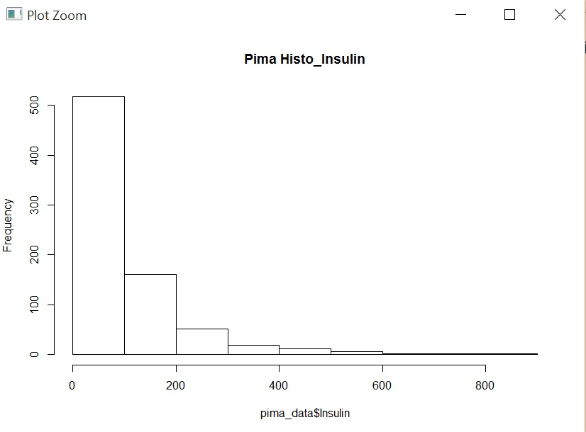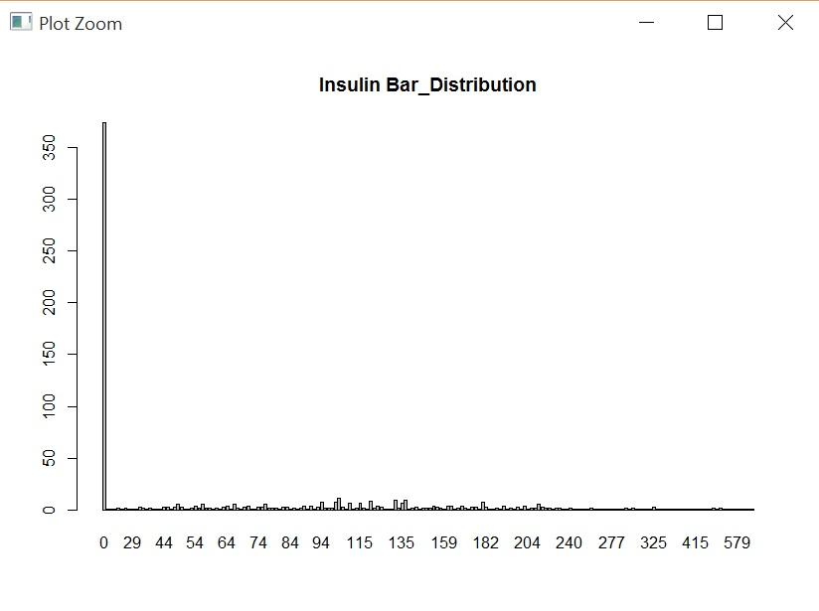

**NOTE** 🡪 BMI is Normally Distributed.

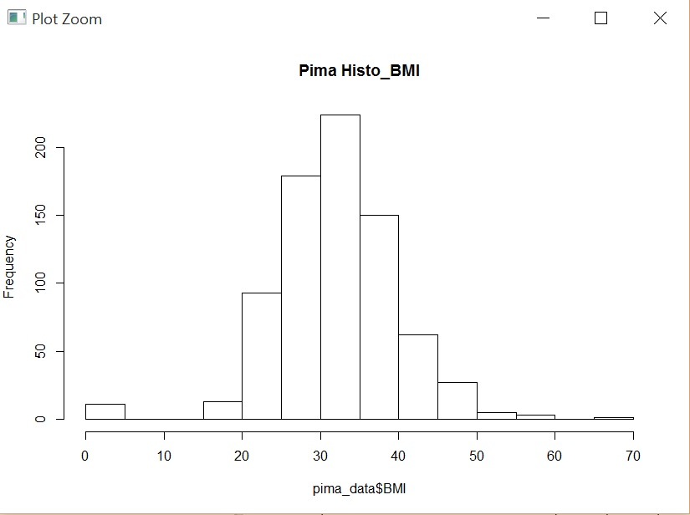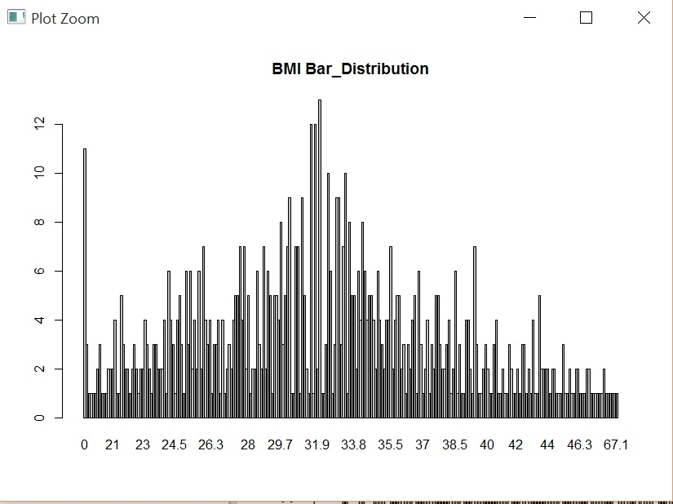

**NOTE** 🡪 Pedigree is not Normally Distributed.

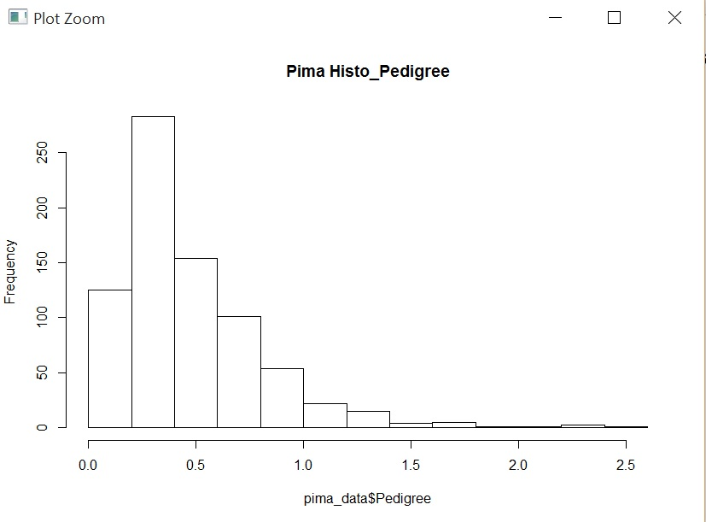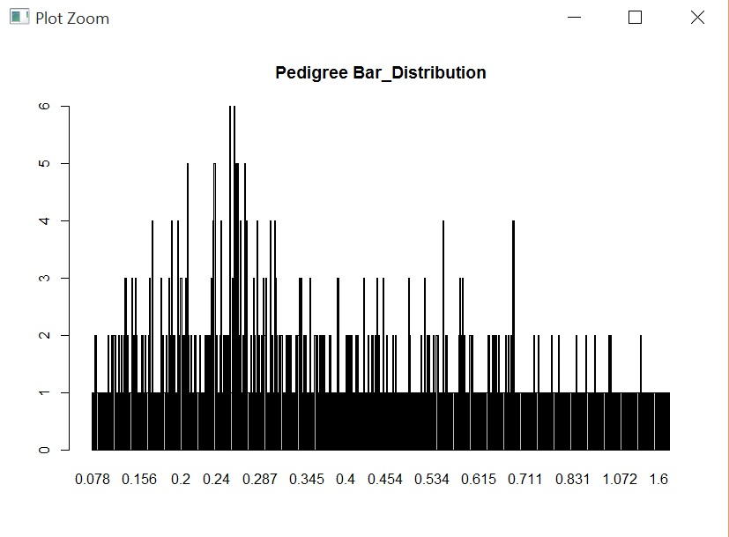

**NOTE** 🡪 Age is not Normally Distributed.

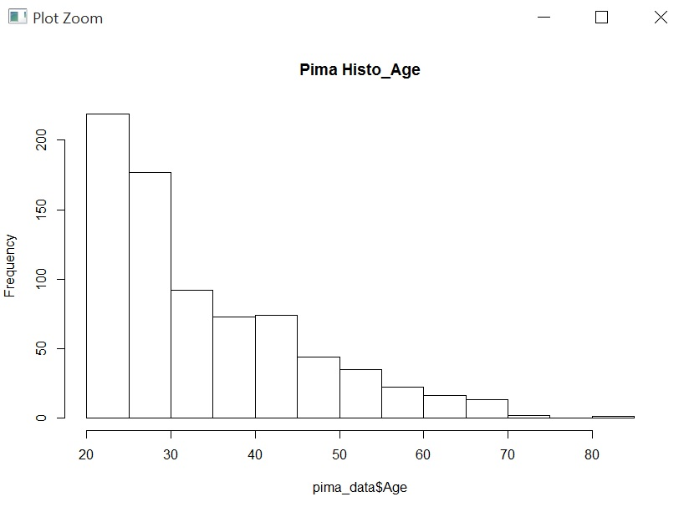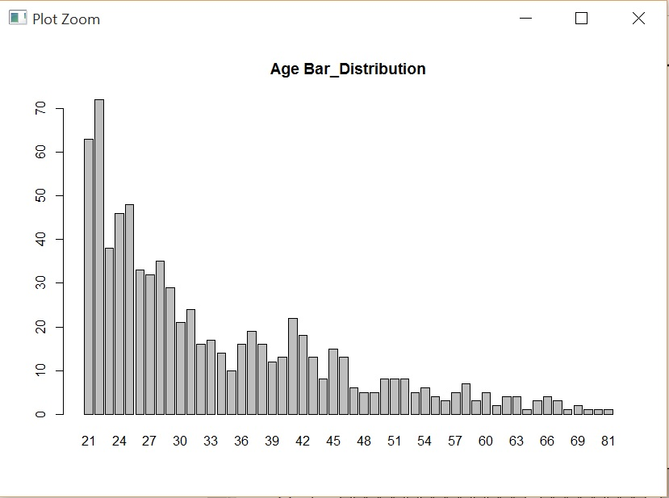

1. Correlation between each of attributes & class variable

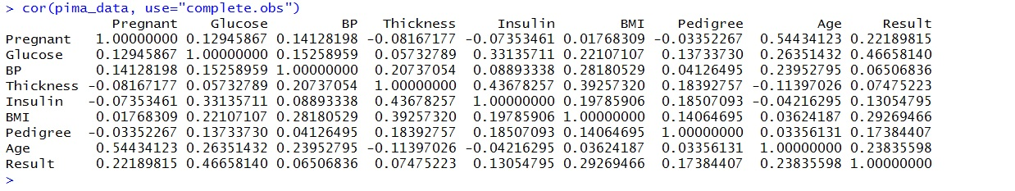

Glucose has the strongest correlation with the output Result class variable.

1. Correlation between all 8 pairs. Which two attributes have the highest mutual correlation?

